**User Guide for Souvenir Store**

**Version 1.0**

**REVISION HISTORY**

|  |  |  |  |
| --- | --- | --- | --- |
| **Version** | **Author** | **Release Date** | **Summary of Changes** |
| 1.0 | SE23PT02 | 03/04/2015 | Initial Version |
|  |  |  |  |

Table of Contents

**1.** **INTRODUCTION** 4

**2.** **LOGIN** 4

**3.** **STORE KEEPERS** 5

**4.** **CATEGORY** 7

**5.** **VENDOR** 8

**6.** **PRODUCT** 13

**7.** **DISCOUNT** 14

**8.** **MEMBERS** 18

**9.** **BILLING** 20

**10.** **REPORTS** 22

**Transactions Search Screen** 22

**Transactions Details Screen** 25

**Transactions Report Screen** 26

**11.** **LOGOFF** 27

1. **INTRODUCTION**
   1. **Purpose**

This document serves as a guide to the user for using the Souvenir Store application. This document explains the features and functions of each menu item in the application

* 1. **Scope**

This document covers only the usability of the application and no technical or implementation details are covered

1. **LOGIN**
   1. **Description**

The login will allow the user to login to the application

* 1. **Screen**

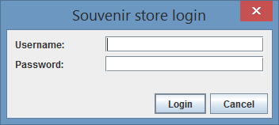

* 1. **Usage**

1. Provide valid User Id and Password and Click “Login” button to login to the application
2. **STORE KEEPERS**
   1. **Description**

The store keeper screen will allow the user to add new store keepers to the system and modify their passwords.

* 1. **Screen**

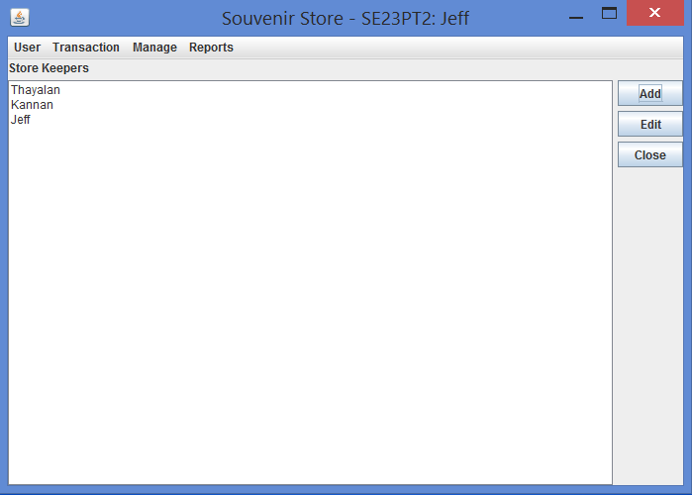

* 1. **Usage**

**Add New Store Keeper**

1. Click on the "Add" button in Store Keeper panel. System opens the "Add StoreKeeper" dialog.

2. Fill the store keeper name, password and confirm password in the appropriate fields.

3. Click "Ok" button to save the store keeper to the system.

4. The newly created store keeper will be listed in the panel, if submission is successful.

**Edit Store Keeper**

1. Select the store keeper in the list that you're going to modify.

2. Click on the "Edit" button in Store Keeper panel. System opens the "Edit StoreKeeper" dialog.

3. Fill the current password, new password and confirm password in the appropriate fields.

4. Click "Ok" button to save the modified store keeper to the system.

1. **CATEGORY**
   1. **Description**

The login will allow the user to login to the application

* 1. **Screen**



* 1. **Usage**

1. Provide valid User Id and Password and Click “Login” button to login to the application
2. **VENDOR**

To maintain the vendor offered by the souvenir store, click “Manage” in the menu bar -> “Inventory” -> Vendors.

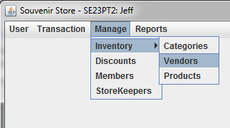

The maintenance panel will be displayed as below,

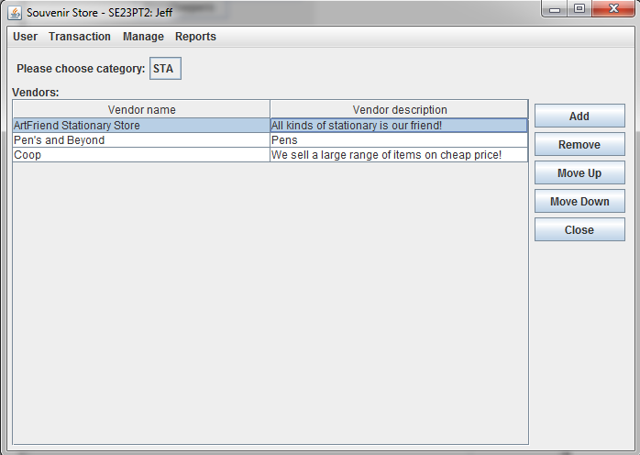

**Adding of Vendor:**

First choose the category, then press the *“Add”* button on the “Vendor” panel, the Add Vendor dialog will be shown.

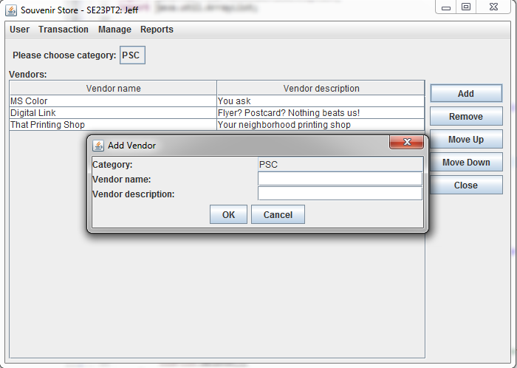

Vendor name and vendor description are mandatory.

If the conditions are not met, then an error message will pop up to remind admins that some input values are missing. In this case, the entry will NOT be added to data store.

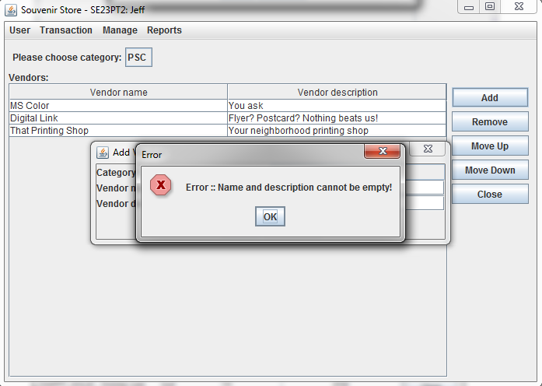

If add duplicate vendor for one category, one error message will popup.

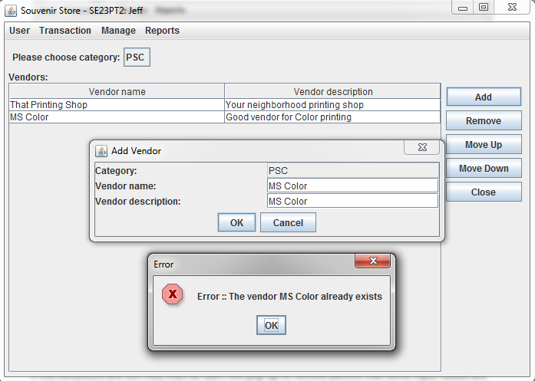

**Remove of Vendor:**

Click any record on the Vendor panel, then ‘Remove’ button on the right, a confirmation dialog will pop up to ask if you confirm to remove this selected vendor.

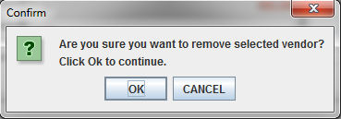

And if you click ‘OK’, the selected vendor will be removed. If you click ‘Cancel’, then nothing will be removed.

**Editing of Vendor:**

Admins are allowed to update vendors on the vendor panel directly. Note that ‘Vendor Name’ is non-editable as it is the primary key for each vendor record.

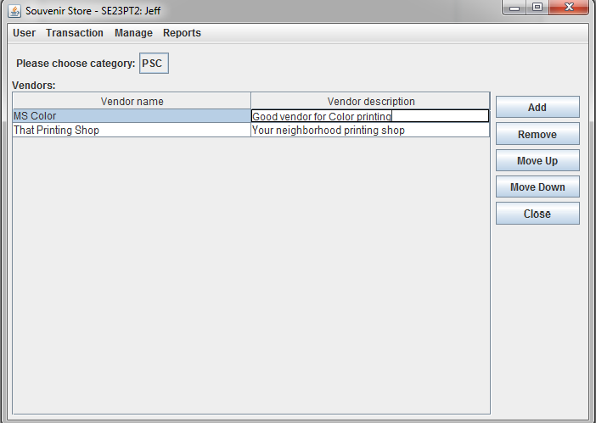

**Change sequence of Vendor:**

Admins are allowed to change the sequence of vendors in the order of preference.

Click any record on the Vendor panel, then ‘Move Up / Move Down” buttons on the right to move the selected vendor to preferred position.

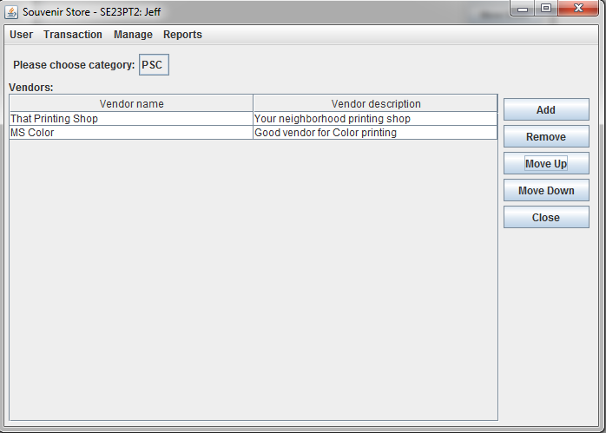

1. **PRODUCT**
   1. **Description**

The login will allow the user to login to the application

* 1. **Screen**



* 1. **Usage**

1. Provide valid User Id and Password and Click “Login” button to login to the application
2. **DISCOUNT**

To maintain the discounts offered by the souvenir store, click “Manage” in the menu bar -> “Discounts”.

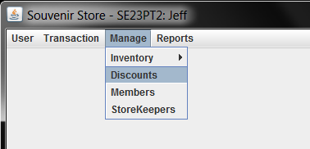

The maintenance panel will be displayed as below,

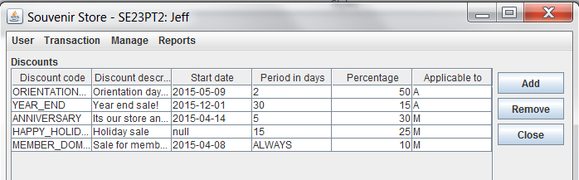

**Adding of Discounts:**

Press the *“Add”* button on the “Discounts” panel, the Add Discount dialog will be shown.

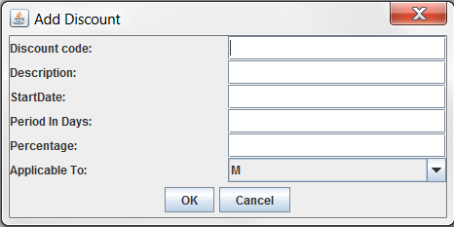

Admins are supposed to enter all the fields with the following two conditions/checks

* StartDate: must follow the ‘yyyy-MM-dd’ format
* Period In Days: must be numeric value

If the conditions are not met, then an alert will pop up to remind admins that some input values are invalid. In this case, the entry will NOT be added to data store.

For example, in the below snapshot, the Start Date was entered as ‘20140802’ which doesn’t follow the prescribed format. Consequently, an alert pops up.

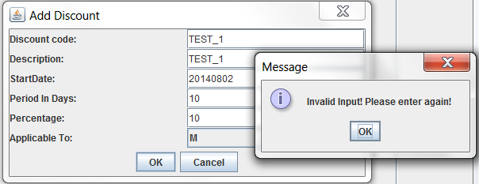

Now if you correct the Start Date to ‘2014-08-02’ then a new record will be added and displayed on the main UI.

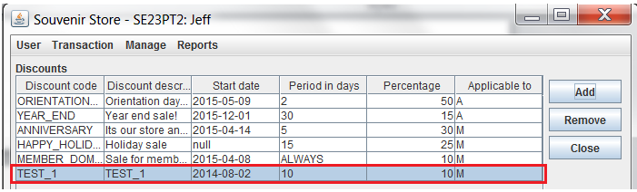

**Remove of Discounts:**

Click any record on the main UI, then ‘Remove’ button on the right, a confirmation dialog will pop up to ask if you confirm to remove this selected discount.

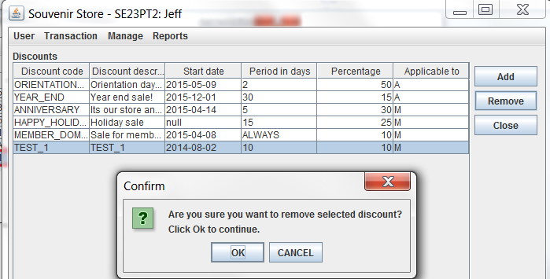

And if you click ‘OK’, the selected discount will be removed from main UI. If you click ‘Cancel’, then nothing will be removed.

**Editing of Discounts:**

Admins are allowed to update discounts on the main UI directly. Note that ‘Discount Code’ is non-editable as it is the primary key for each discount record.

The editing of other fields will be like below,

* **Discount description**

This is a normal string field. Admins can simply click this field and update the string value there.

* **Start Date**

Double click this field to launch a date chooser as below. The chooser allows admin to find any date within +/-20 years range.

To change year, admins should click the combo box.

To change month, admin should click the left/right button.

To select date, admin should directly pick a date from the main chooser.

Then click ‘OK’ to confirm you have selected a date.

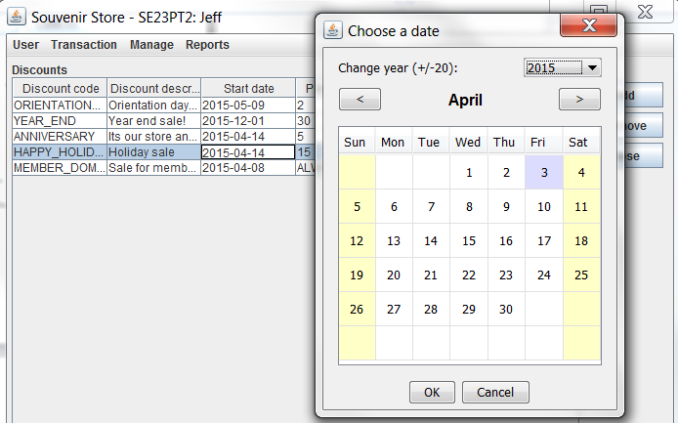

If an invalid date (i.e., any empty cell) was picked, the UI will pop up an alert dialog to remind you.

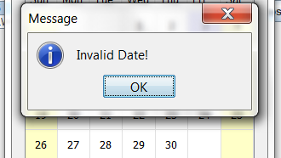

* **Period in Days**

This field must contain only numeric characters. Nonetheless, admins are allowed to enter “ALWAYS” to indicate this discount is a permanent one.

If the entered value is neither “ALWAYS” nor numeric characters, an “Invalid value” alert will pop up to remind you (i.e., highlighted cell below – “15s” is not a value input).

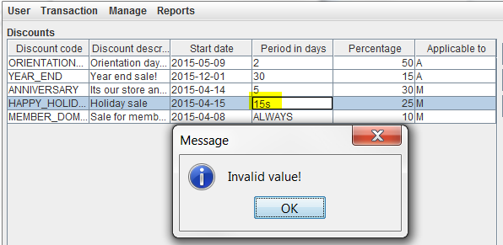

* **Percentage**

This field was designed as “double” date type.

Admins should enter only numeric values. Otherwise it won’t be updated.

* **Applicable To**

This field is designed as a combo box.

Admins should select either “M” or “A” from the drop-down list.

* “M” means it is applicable to members only
* “A” means it is applicable to all customers

1. **MEMBERS**
   1. **Description**

The member will allow the user to add Members

* 1. **Screen**

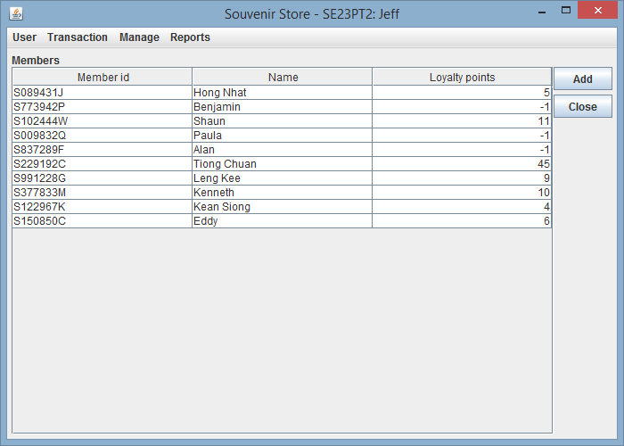

*Member List*

* 1. **Usage**

**Adding Members**

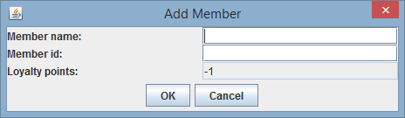

*Adding Member*

1. Press the *“Add”* button on the members panel, the Add Member dialog will be shown.
2. You need to fill in the member name, member id in the provided text field. Loyalty points always start at -1 and is not editable.
3. Press *“OK”* to confirm addition. Press *“Cancel”* to go back to the members panel.

**Editing Members**

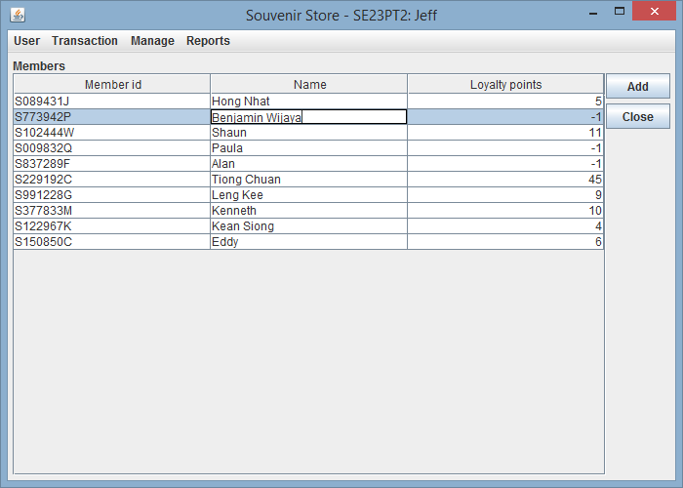

*Editing Member*

1. Simply click on the member’s name that you want to edit. Only the name is editable.
2. **BILLING**
   1. **Description**

The billing screen will allow the user to bill the items, auto-compute discounts, redeem points for members, make the payment and print the receipt upon confirmation.

* 1. **Screen**

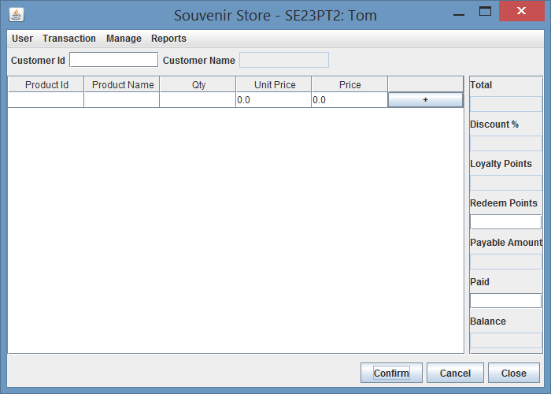

* 1. **Usage**

1. The Billing screen is under Transaction Menu
2. Enter the “Customer Id” (Member ID) and system would do auto-search the members to populate Customer Name, Loyalty points and discount if any
3. If member not found, system would alert the user and continues as “PUBLIC” customer
4. Choose Product Id from the table and system would auto-populate the Product name and unit price
5. The system would auto-populate the qunatity as 1 and computes the price
6. User can change the qty at any time before confirm
7. Click “+” button to add the item to the cart and continue order the next item
8. The previously added item will have “x” button in the last column of the table
9. Click the “x” button to remove the item from the list
10. After adding each item, system auto computes the total, payable amount and the balance (if “Paid” amount was entered)
11. The loylaty points will be displayed for Members
12. Enter points to be redeemed under “Redeem Points” field to deduct points in the payable amount
13. Click “Confirm” to confirm the order, make the payment and print the receipt
14. Click “Cancel” to clear the shopping cart without confirm and make new order
15. Click “Close” to save the shopping cart in session and go to the home page
16. Shopping cart will be auto saved in to the session if user moves to some other screen but will be lost when logged out
17. **REPORTS**

**Transactions Search Screen**

* 1. **Description**

Transaction search page will allow user to find transactions between particular date.

* 1. **Screen**

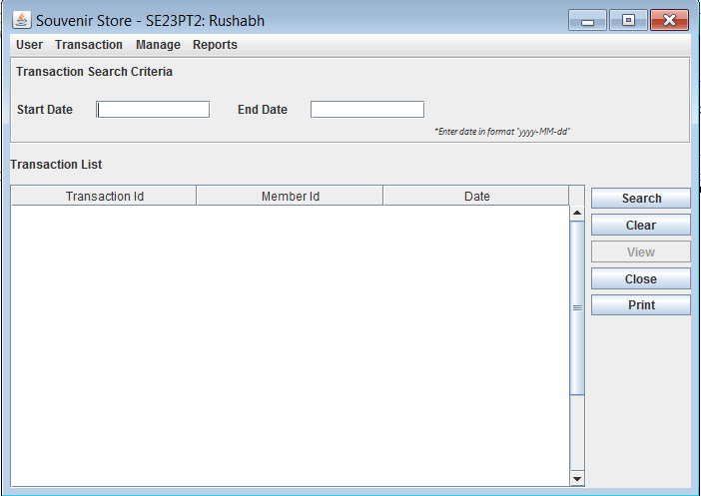

Figure 1: Initial Screen (View button disabled)

* 1. **Usage**

1. Goto “Reports” tab and select Transaction to go to Transaction search screen. (Figure1)
2. Start Date and End Date are accepted in format “yyyy-MM-dd”.
3. If Start date exceeds End Date then, system will throw error.

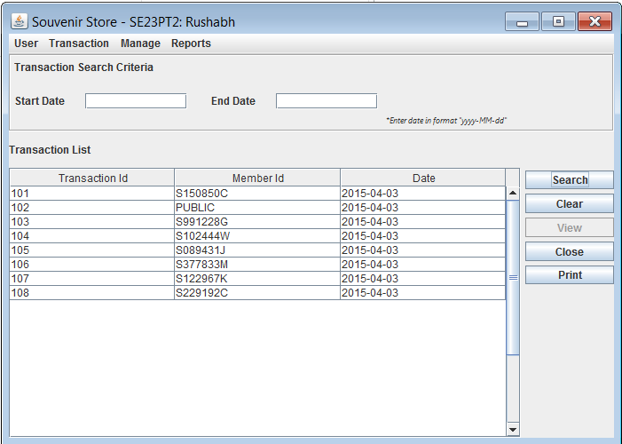

Figure 2 : Transaction List results after clicking "Search" button

* 1. **Usage**

1. “Search” button facilitates user to search transactions between particular dates.
2. After clicking “Search” button if Start Date and End Date both are empty then user will get entire list of Transactions
3. After clicking “Search” button if Start Date is empty and End Date is entered then user will get all Transactions - on or before the End Date.
4. After clicking “Search” button if Start Date is entered and End Date is empty then user will get all Transactions - on or after the Start Date.
5. To retrieve transactions for a particular date user should enter same values of start and end date.

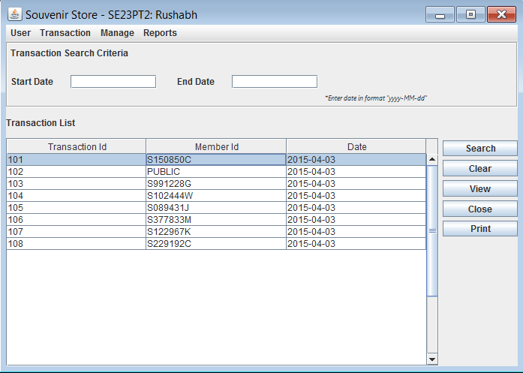

Figure 3 : Selecting a Transaction from List (View button enabled)

* 1. **Usage**

1. After clicking search button user will get list of transaction sorted in ascending order of their transaction Id.
2. Cells in the displayed transaction List are non-editable.
3. User would be able to select only a single record from the displayed Transaction List.
4. Clicking “Clear” button clears the data entered in the start date and end date fields.
5. “View” button will get enabled once the row is selected from the Transaction list.
6. “Close” button will help user navigate to the main window.

**Transactions Details Screen**

* 1. **Description**

Transaction details page will allow user to see product related details like Product id, name, description, Quantity etc.

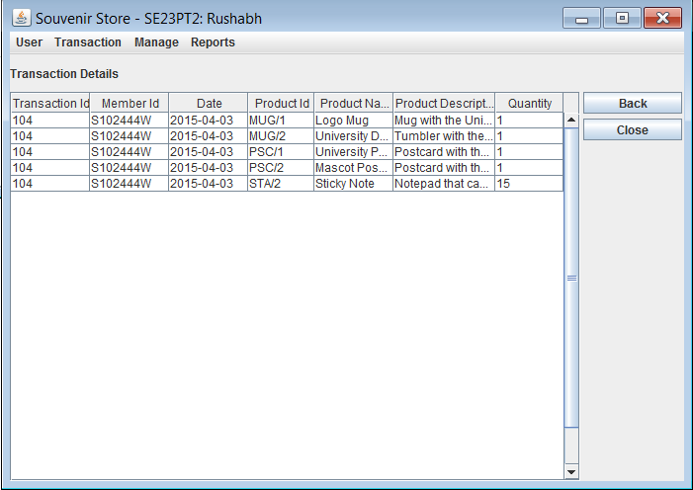

Figure 4 : Transaction details page after clicking View button

* 1. **Usage**

1. On click of “view” button after selecting a particular transaction you will get List of transactions with product details(like product Id, product name, quantity, product description) sorted by the ProductId.
2. When user clicks on “Back” button the user’s search criteria would be retained along with the search results in Transaction search screen.

**Transactions Report Screen**

* 1. **Description**

Clicking “Print” button on Transaction search page will generate report with all transactions between given date range sorted with transaction Id in ascending order. Along with the product name, description, order quantity etc sorted with product Id for a particular transaction.

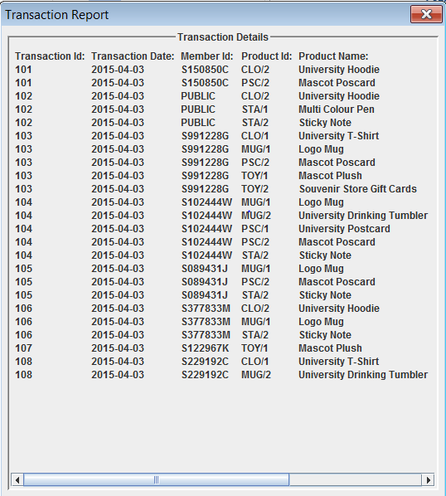

Figure 5 : List of Transactions

1. **LOGOFF**
   1. **Description**

The logoff will allow the user to logout from the application

* 1. **Usage**

1. Click “Logoff” under the User menu to logout of the application